# Title of your contribution for the 3rd AWMS 2019

First F. Author1, Second S. Author2

1Affiliation of the first author, address, country

2Affiliation of the second author, address, country

All presenters are requested to prepare and submit a **one-page** abstract according to the instructions given here. The abstract book will be available at the conference and will be published online.

**The deadline for abstract submission is the 6th of February, 2019.**

Abstracts should be sent as attachments (lastname_abstract.doc) to: AWMS2019@ustc.edu.cn

The abstracts should be prepared as MS-Word documents as shown here and detailed below. The complete text of abstracts (written in English) must fit into **one** A4 page with the margins used in this template. The names of authors attending the conference should be underlined in the author list. References are cited in the text like this [1] and should be formatted as shown in the reference section below. Please, do not use page numbering in your abstract.

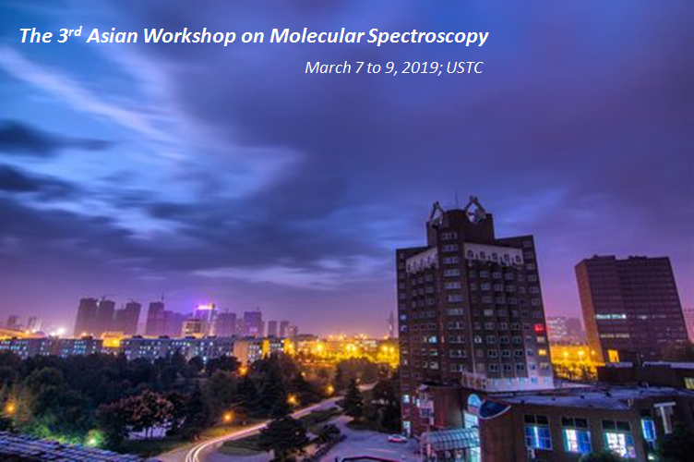

Fig. 1: The abstract may include equations and figures. They should be embedded in the abstract document.

More information about the conference: (<http://atta.ustc.edu.cn/AWMS2019>). NOTE: It is the author’s responsibility to read through the abstract carefully before submitting it, and check that it complies with the required abstract formatting. For each abstract, conference registration for one of the authors is required.

References:

[1] First F. Author, Second S. Author, *Phys. Rev. B* **11**, 1111 (2001).

[2] First F. Author, Second S. Author, *Phys. Rev. B* **22**, 2222 (2002).

Indicate your choice :

□ Oral Presentation □ Poster Presentation